Textile Auxiliaries
Desizer
Products | Purpose | Appearance Ionicity | Technical Advantages
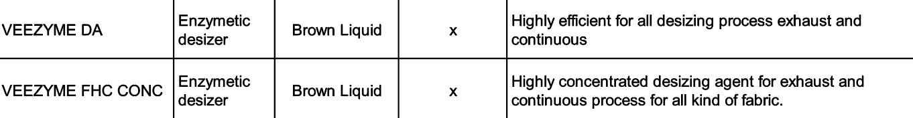
Wetting Agent
Products | Purpose | Appearance Ionicity | Technical Advantages
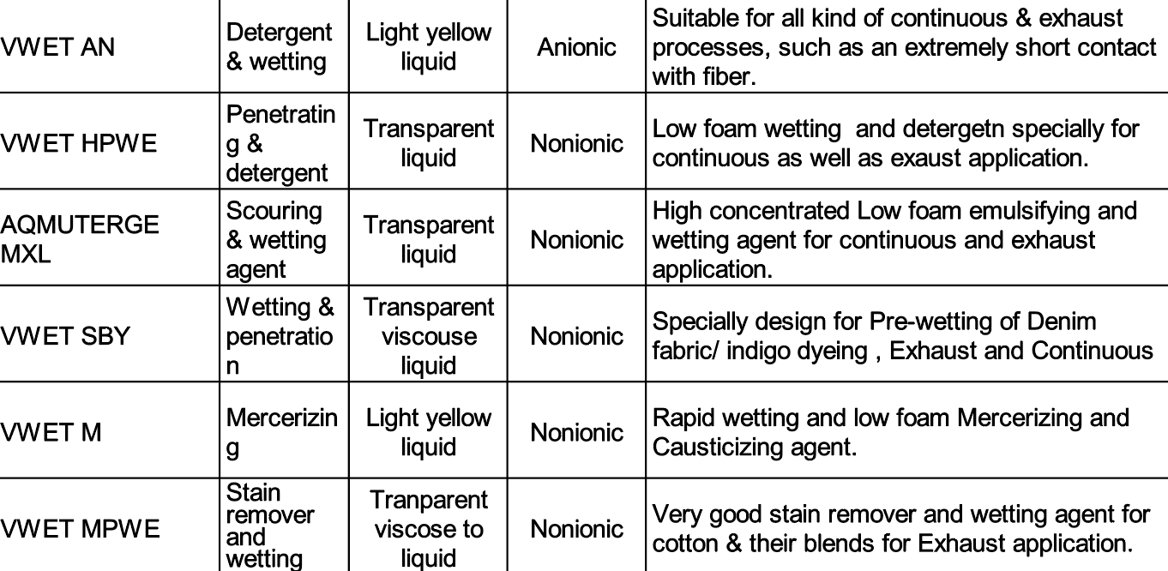
Lubricant Agent
Products | Purpose | Appearance Ionicity | Technical Advantages

Defoamers
Products | Purpose | Appearance Ionicity | Technical Advantages

Sequestering Agent
Products | Purpose | Appearance Ionicity | Technical Advantages
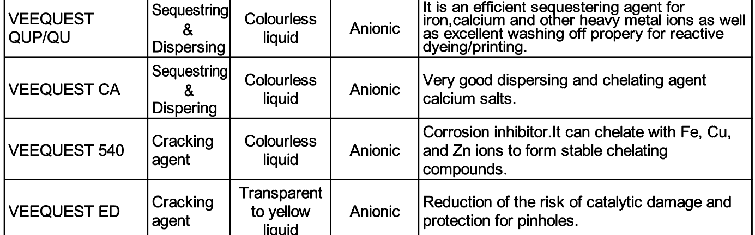

Stabilizer
Products | Purpose | Appearance Ionicity | Technical Advantages
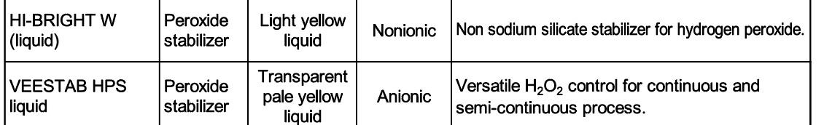

Buffer
Products | Purpose | Appearance Ionicity | Technical Advantages
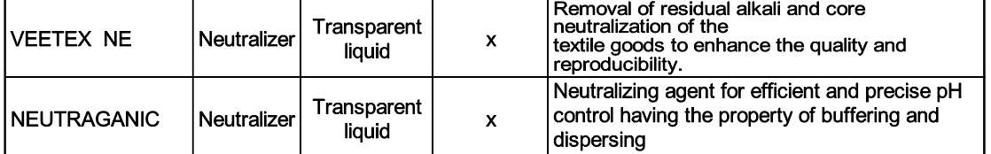

Dyeing Auxiliaries
Products | Purpose | Appearance Ionicity | Technical Advantages
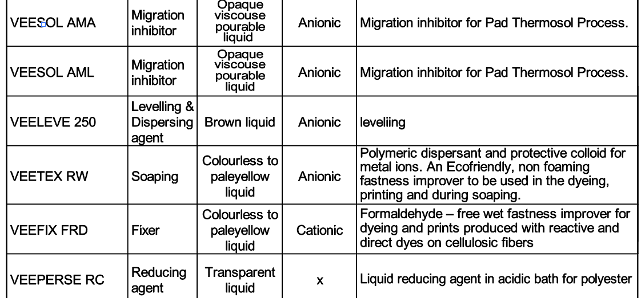

Finishing
Products | Purpose | Appearance Ionicity | Technical Advantages
